

GOVERNMENT OF INDIA

**MINISTRY OF SKILL DEVELOPMENT & ENTREPRENEURSHIP**

DIRECTORATE GENERAL OF TRAINING

**NATIONAL SKILL TRAINING INSTITUTE**

NSTI Campus, Salt Lake (E) Kolkata,700091

**CERTIFICATE**

This is to certify that following trainees have completed their project titled

**“NSTI Smart Cloud Campus”**

**For IBM Program – IT, Networking and Cloud (Technical Diploma)**

|  |  |
| --- | --- |
| **ROLL NO** | **NAME** |
| ADIT19AU00537 | Niharika Singh |

**Miss Arpita Roy** **Mr. K.L. Kuli** **Mr. Sarbojit Neogi**

IBM Faculty To/ADIT Director AD/Section In-charge

**Acknowledgement**

We are grateful to Ms. Arpita Roy, whose guidance, inspiration and constructive suggestions throughout the project has resulted in a successful completion of this project. Without their willing disposition, cooperation this project could not have been completed in due time.

Date :27/06/2021

**TABLE OF CONTENTS**

*Topics*

* Acknowledgement
* Declaration
* Abstract
* Feasibility study
* Introduction
* Objective
* Project description
* Software environment
* Project category
* Testing
* Future scope
* System design
* How to create a dynamic web project
* How to create jsp files
* How to add tomcat server and run on locally
* Screenshots
* How to add Bluemix server and push application on cloud
* screenshots
* Source code
* Conclusion
* Reference

## Declaration

I Hervey declare that the project entitled " Phone Book App " is the work done during the period from (June 01/06/2021 to June 07/06/2021) and is submitted in the practical fulfillment of the requirements for the technology in computer engineering from (NSTI (W) KOLKATA) the results embodied in this project have not been submitted to any other university or institution for the award of any degree or diploma.

Shri G.C Ramamurthy

Head of Office / Principal

[Gc-rama@yahoo.com](mailto:Gc-rama@yahoo.com)

Mr.Pintu Dey (UDC)

[pintudey@dgt.gov.in](mailto:pintudey@dgt.gov.in)

# ABSTRACT

This website is specially developed to help mobile users. The project Phonebook application manages and maintains the records of mobile users, register detail of user. I have attempted to un-complicate the onerous process of the phonebook application by using a prepared & Modular technique as well as create a Menu learning boundary. I have attempted to make the project as user-friendly and extensible as possible, so its use and extension can be done without much endeavor.

***F E A S I B I L I T Y S T U D Y***

Preliminary investigation examines project feasibility, the likelihood the system will be useful to the organization & mobile users. The main objective of the feasibility study is to test the Technical

Operational and save the time feasibility for adding new modules and debugging old running system. All system is feasible if they are unlimited resources and infinite time. There are aspects in the feasibility study portion of the preliminary investigation.

* *Technical feasibility*
* *Operational feasibility*

## **I N T R O D U C T I O N**

## 

It is estimated that there are more than 600 million mobile phone users around the world – and the number is increasing. The success of mobile phones seems easy to explain: being available anytime and anywhere. If a businessman moves from one place to another, he is available for his company at no extra effort. If the son will be late at home, he can inform his parents. If you have trouble with your car, you can call the breakdown service. Mobile phones are used for communication but also for coordination between people.

***OBJECTIVE***

To make software fast in processing, with the good user interface so that user can store the mobile numbers and about the how many contact his mobile, can add the number with name of person using cloud.

### **PROJECT DESCRIPTION**

This project is all about developing a website for mobile users all contact store in cloud and view contact to all save numbers. The software is designed using java, html, CSS and deploy this application to IBM Bluemix server & locally deploy it tomcat server. Different shop owners can access this software using their own unique login-id and password.

Various software modules have been provided in this software which caters to the needs of the mobile users.

For example, the mobile user can view the contact list of his phone

***S O F T W A R E E N V I R O N M E N T***

*ECLIPSE:*

Eclipse is an integrated development environment (IDE) used in computer programming.[5] It contains a base workspace and an extensible plug-in system for customizing the environment. Eclipse is written mostly in Java and its primary use is for developing Java applications, but it may also be used to develop applications in other programming languages via plug-ins, including Ada, ABAP, C, C++, C#, Clojure, COBOL, D, Erlang, Fortran, Groovy, Haskell, JavaScript, Julia,[6] Lasso, Lua, NATURAL, Perl, PHP, Prolog, Python, R, Ruby (including Ruby on Rails framework), Rust, Scala, and Scheme. It can also be used to develop documents with LaTeX (via a TeXlipse plug-in) and packages for the software Mathematica. Development environments include the Eclipse Java development tools (JDT) for Java and Scala, Eclipse CDT for C/C++, and Eclipse PDT for PHP, among others.

*JAVA (JDK):*

The Java Development Kit (JDK) is an implementation of either one of the Java Platform, Standard Edition, Java Platform, Enterprise Edition, or Java Platform, Micro Edition platforms [1] released by Oracle Corporation in the form of a binary product aimed at Java developers on Solaris, Linux, macOS or Windows. The JDK includes a private JVM and a few other resources to finish the development of a Java application.[2] Since the introduction of the Java platform, it has been by far the most widely used Software Development Kit (SDK). [citation needed]

*TOMCAT:*

The Apache Tomcat software is an open-source implementation of the Jakarta Servlet,

Jakarta Server Pages, Jakarta Expression Language, Jakarta WebSocket, Jakarta

Annotations and Jakarta Authentication specifications. These specifications are part of the Jakarta EE platform.

*Project Category: Web-Based Application*

*Available Technologies:*

*Programming Languages:*

HTML, CSS, JavaScript, bootstrap

Runtime: - Tomcat 8.5v server, IBM Bluemix server

*Tools Used:*

Operating System: Windows 10

Eclipse 0xegen 3

Tomcat

Documentation: - MS Word

*Hardware Used:*

Processor: Intel core i3

RAM: 4GB

Hard Disk: 1TB

# Testing

Software testing is a critical element of software quality assurance and represents the ultimate review of specification, design, and coding.

In fact, testing is the one step in the software engineering process that could be viewed as destructive rather than constructive.

A strategy for software testing integrates software test case design methods into a well-planned series of steps that result in the successful construction of software.

Testing is the set of activities that can be planned in advance and conducted systematically.

The underlying motivation of program testing is to affirm software quality with methods that can economically and effectively apply to both strategic to both large and small-scale systems.

## F U T U R E S C O P E

if we want to more easily data excess, then we can also use cloud storage and also make improvement in this project as per user/costumer requirement.

## SYSTEM DESIGN

### DATA FLOW DIAGRAM

A picture is worth a thousand words. A Data Flow Diagram (DFD) is a traditional way to visualize the information flows within a system. A neat and clear DFD can depict a good amount of the system requirements graphically. It can be manual, automated, or a combination of both.

***Use case diagram***

***User***

***home***

***Registrati***

***on***

***Login***

***Add***

***Contact***

***View***

***Contact***

### How to create a Dynamic Web Project

*Step 1 :* Open eclipse

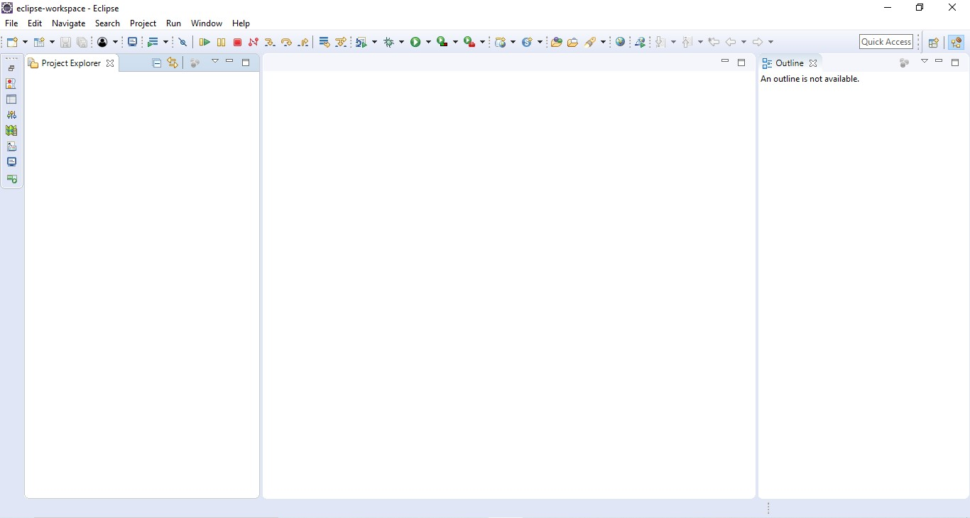

### Click new and Dynamic Web Project

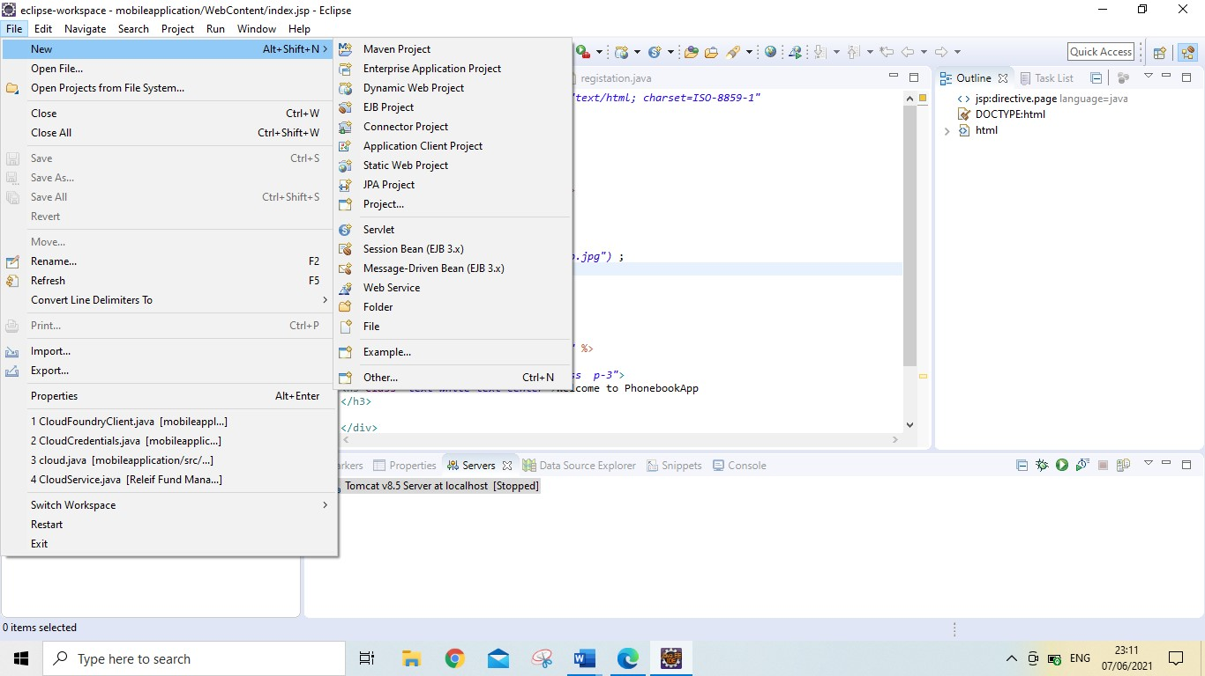

*Provide the project name and click on finish*

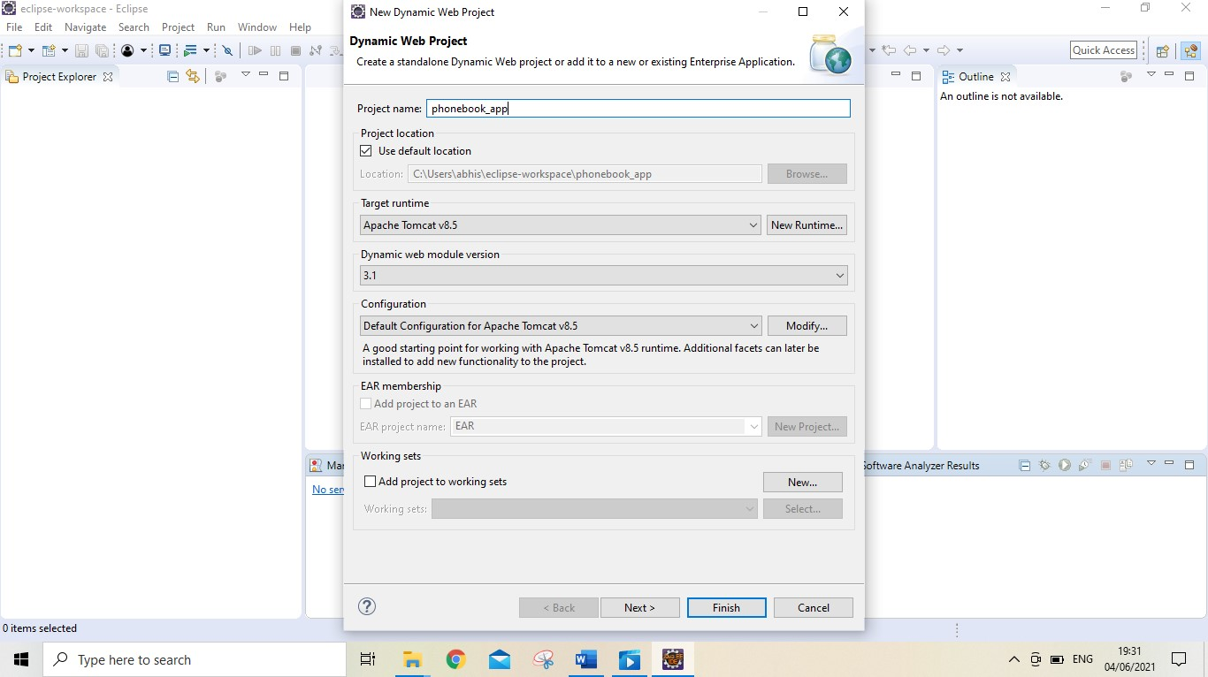

You can able to see dynamic web project

In your Eclipse

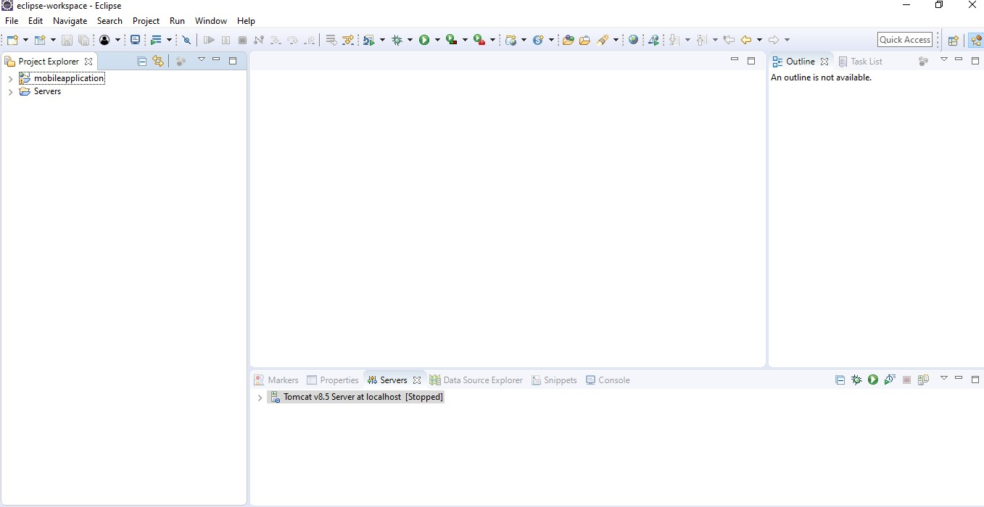

*How to create jsp file*

*Right click on*

*web content*

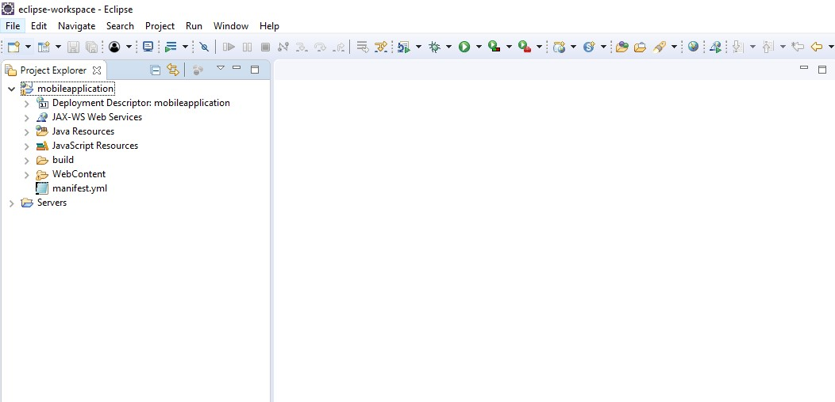

#### Click on new and click on jsp and create jsp file

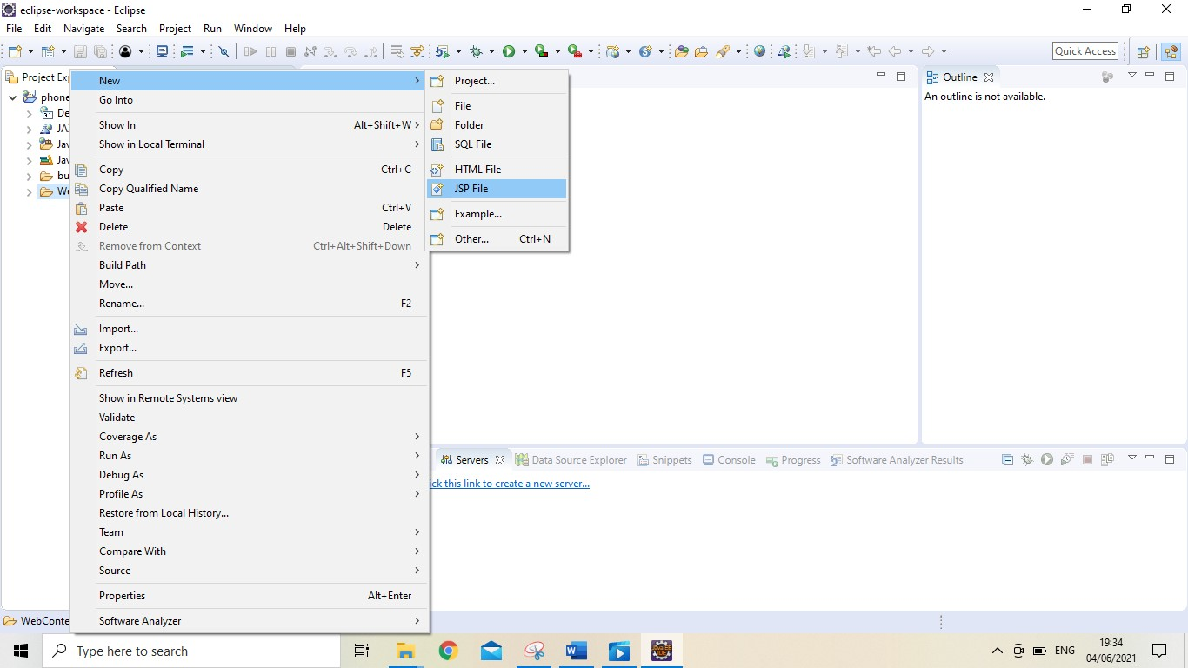

##### I had created those are jsp file

* *Index.jsp is main page* ▪ *Login.jsp for login page* ▪ *Register.jsp for registration* ▪ *Contact.jsp page for add contact*
* *View.jsp page for all view users*
* *Inside webcontent I had create materials folder*
* *Inside this folder*

##### I had Created following files

* *css.jsp & style.css for css file*
* *navbar.jsp for navigation menu*
* *create image and paste here*

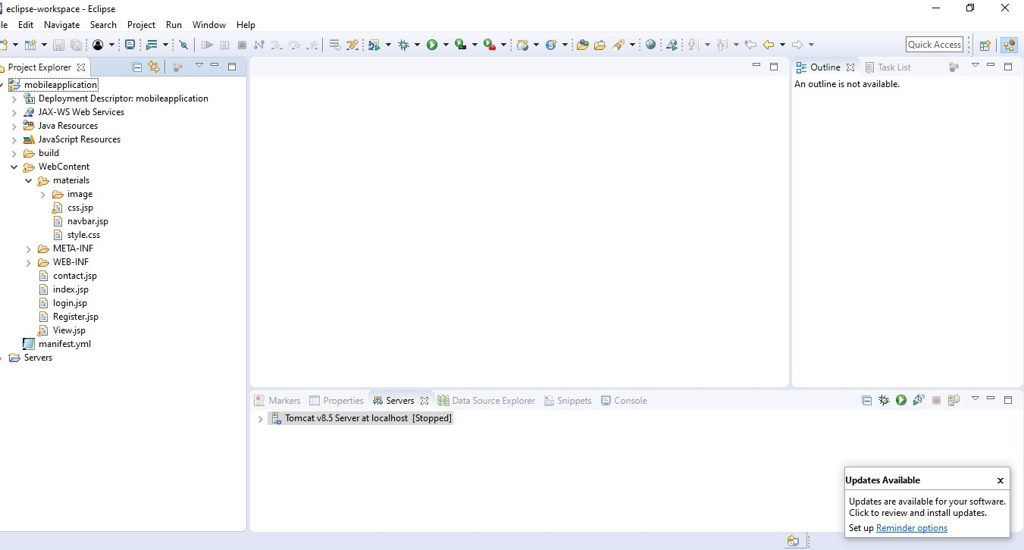

***How to Run mobile Application in locally***

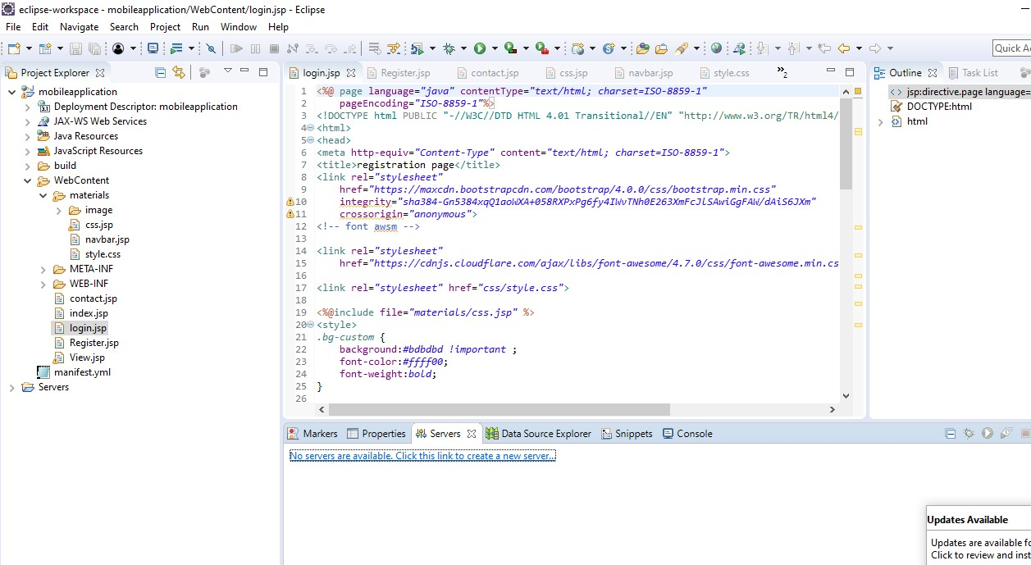

***How to run locally application with tomcat 8.5v***

Go to Apache and select 8.5v

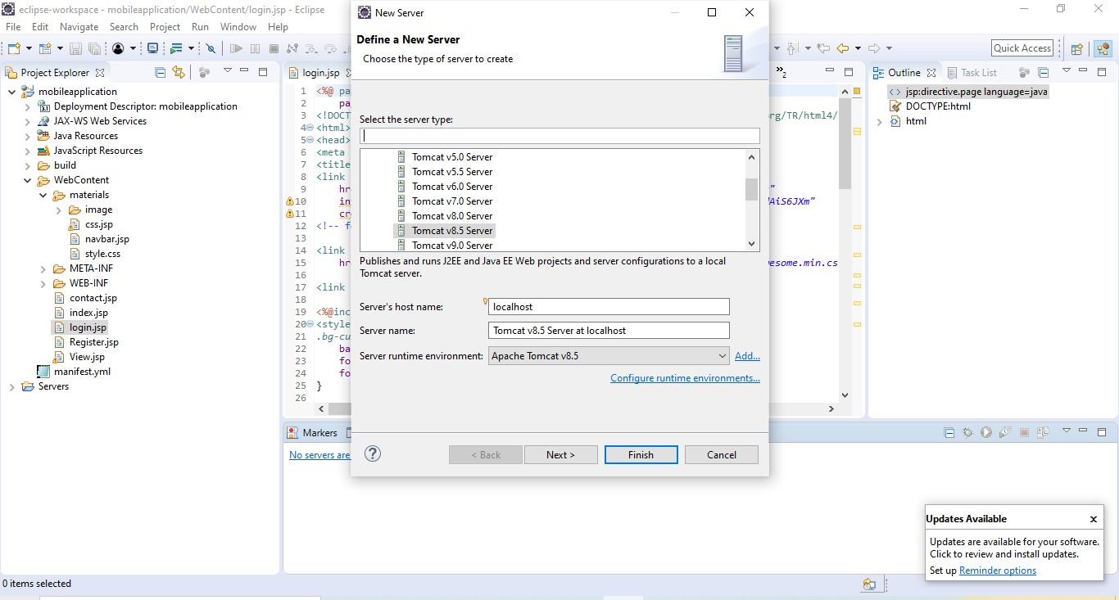

Click finish then Created tomcat server

How to run tomcat

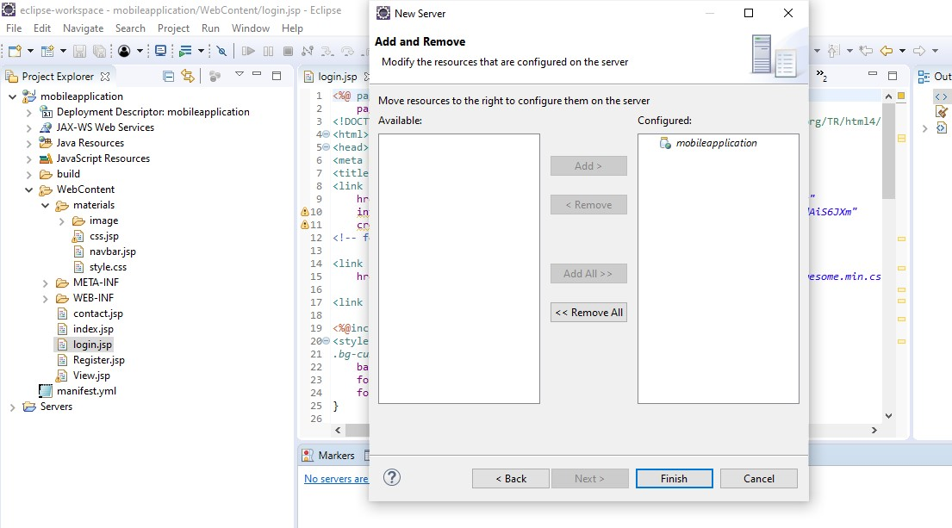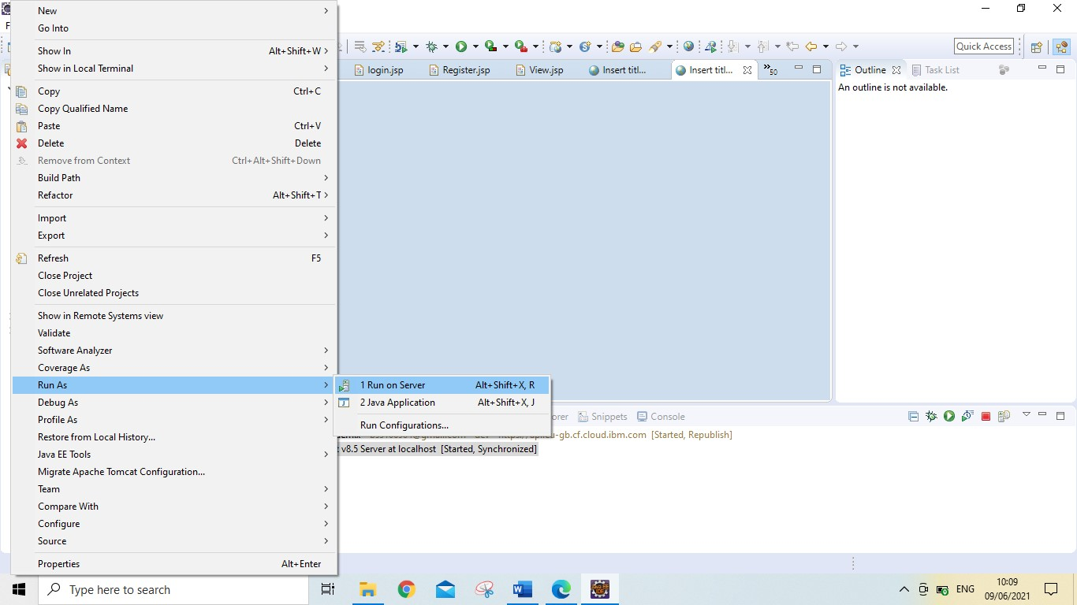

Select tomcat and click on next

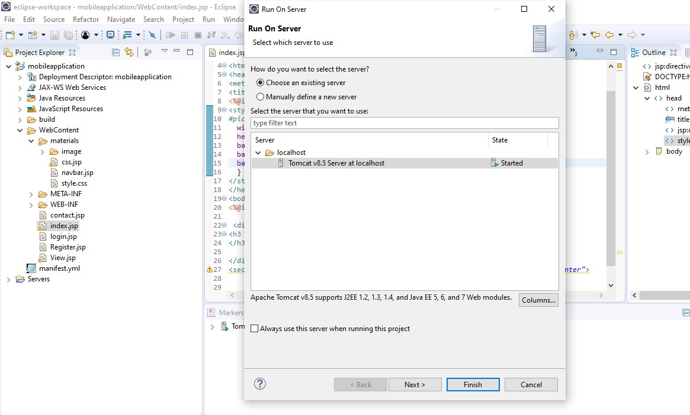

Starting tomcat server in your system

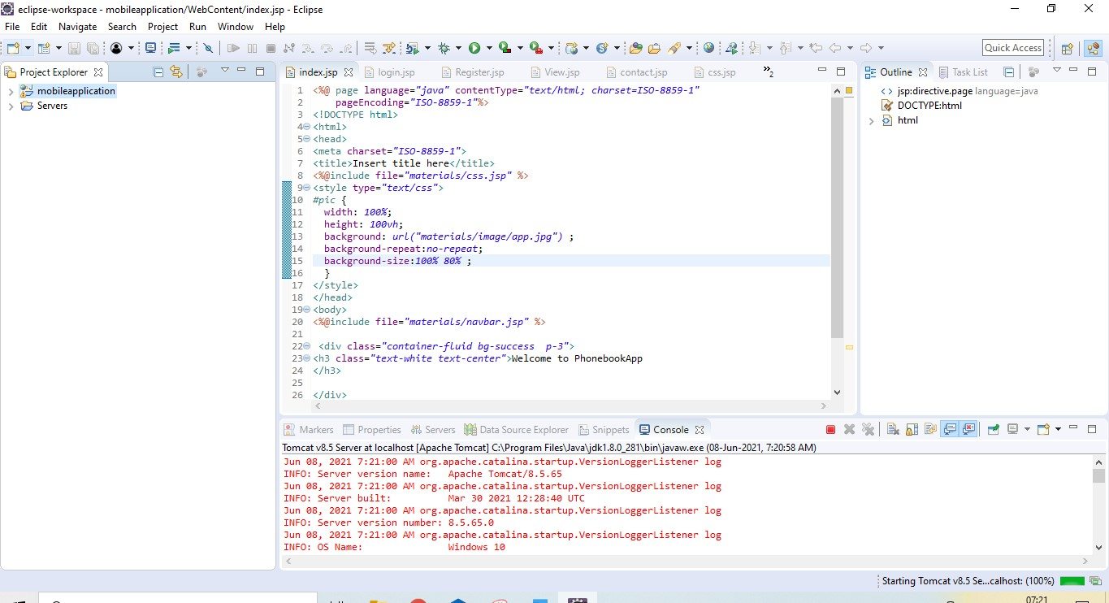

*You can see run locally*

***SCREENSHOTS***

*Home page*

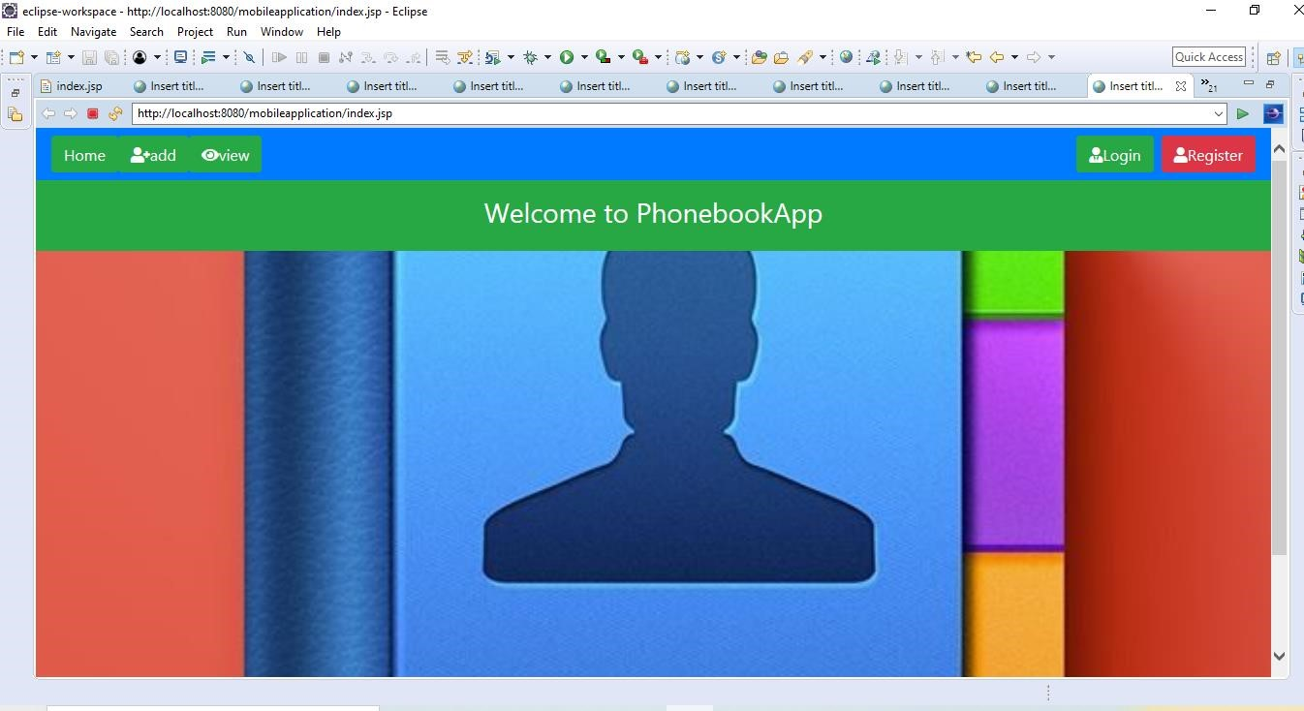

###### Registration page

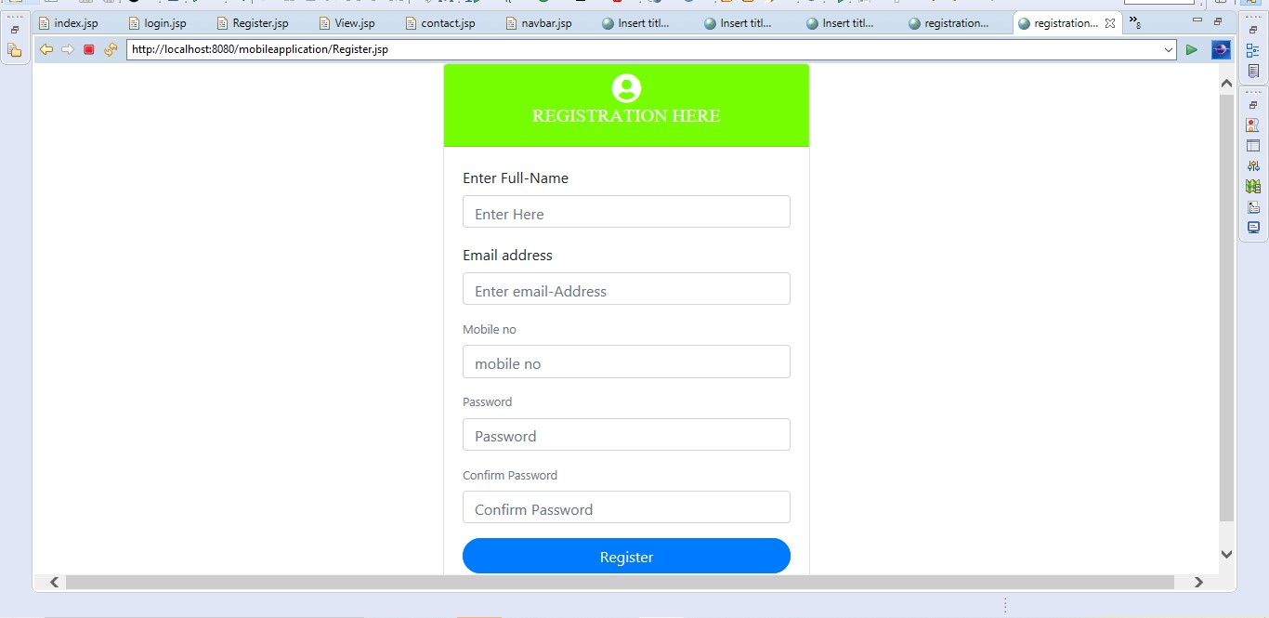

Login page

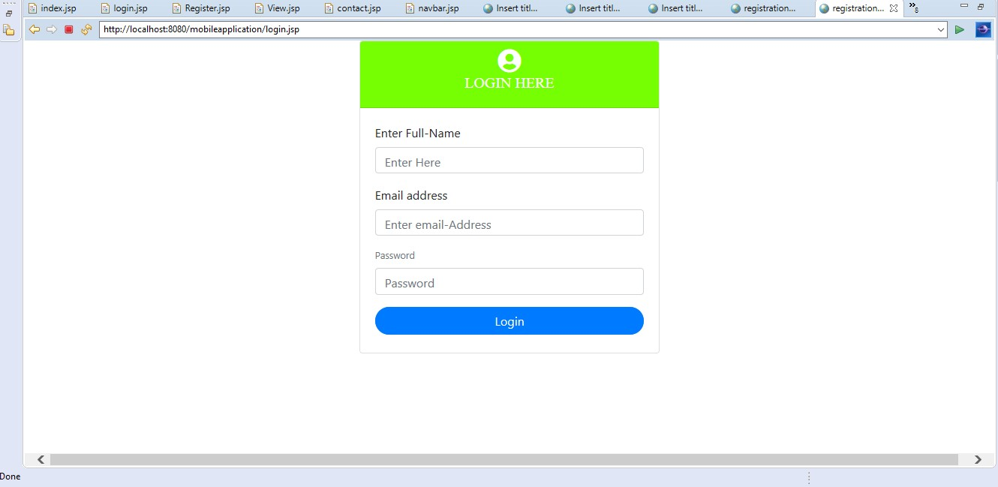

Add contact page

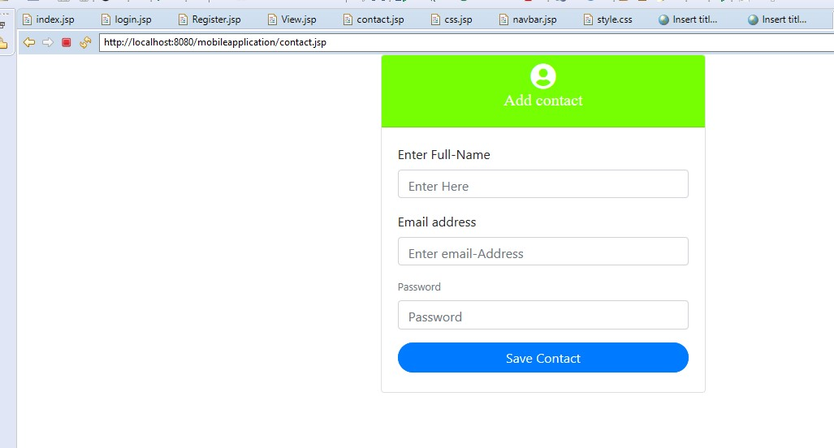

How to add Bluemix server in your application

1. Right click on server
2. Click on new and add server
3. Inside IBM select Bluemix
4. Click on next

Provide the credential

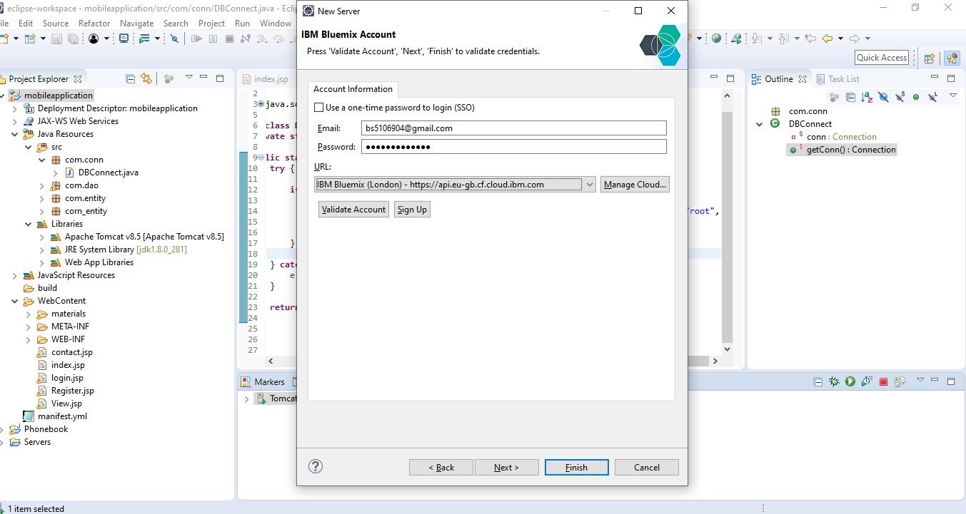

Click on next select dev and click on finish

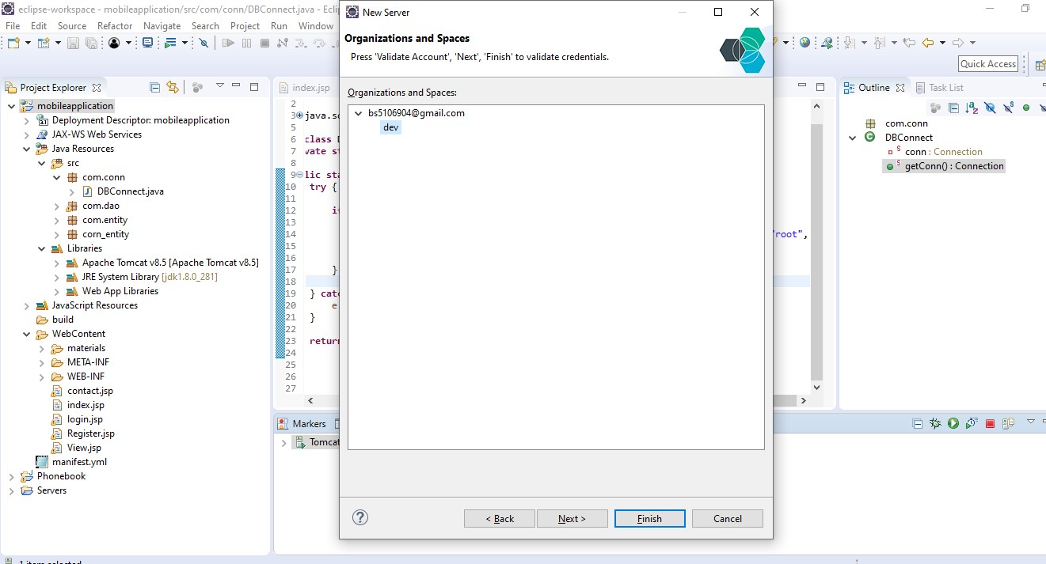

Now our app deploying in cloud foundry

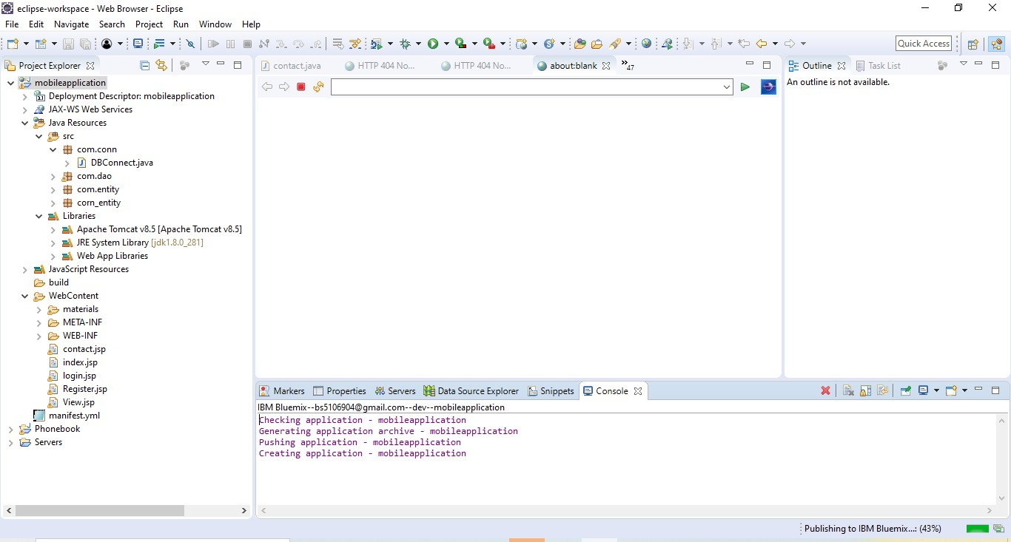

After 5 minutes my app deploy in cloud foundry

You can see my application successfully deploy in cloud foundry

Go inside cf apps

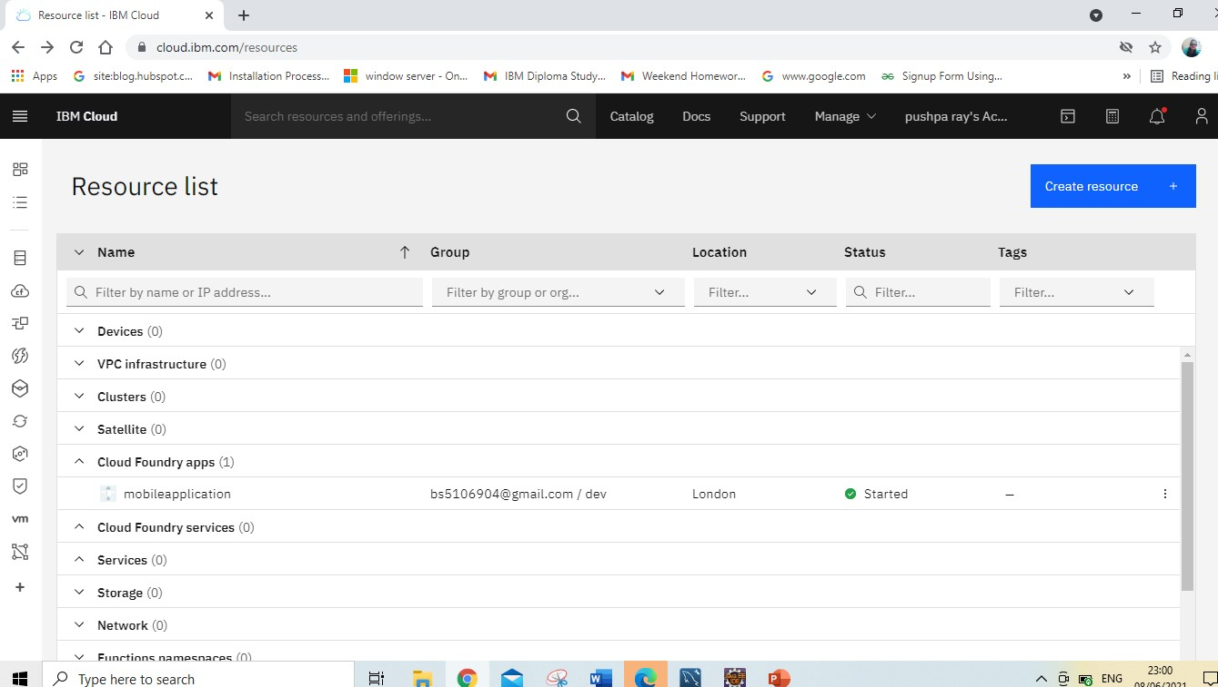

Click on visit URL

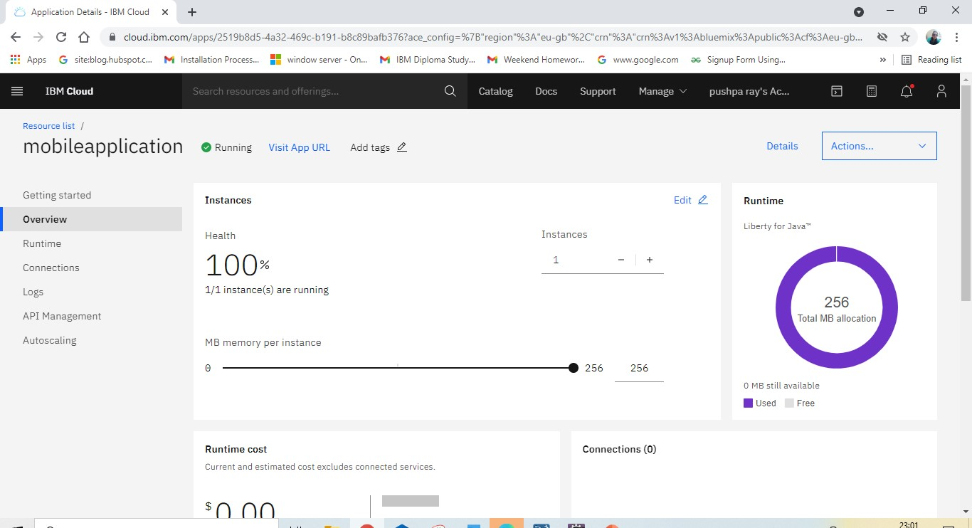

Home page

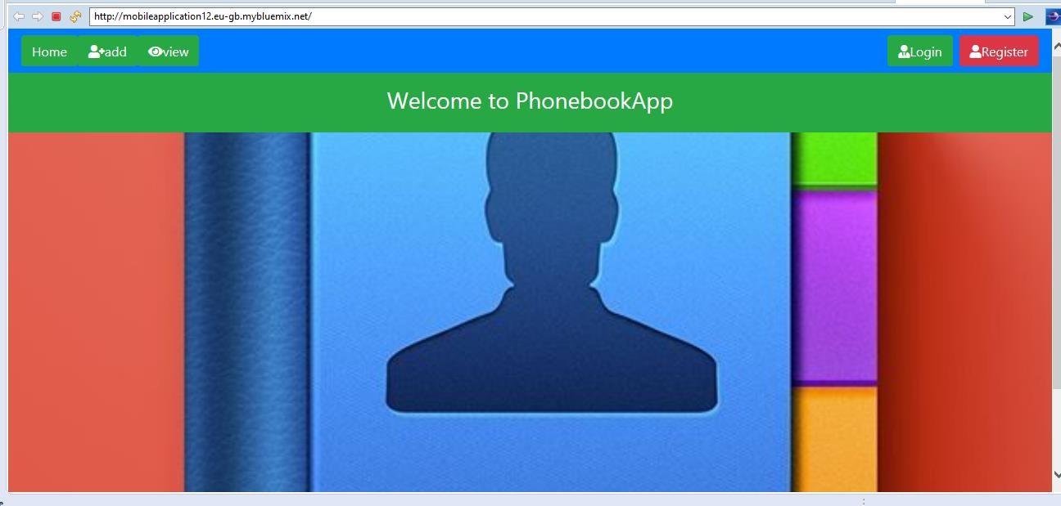

Registration page

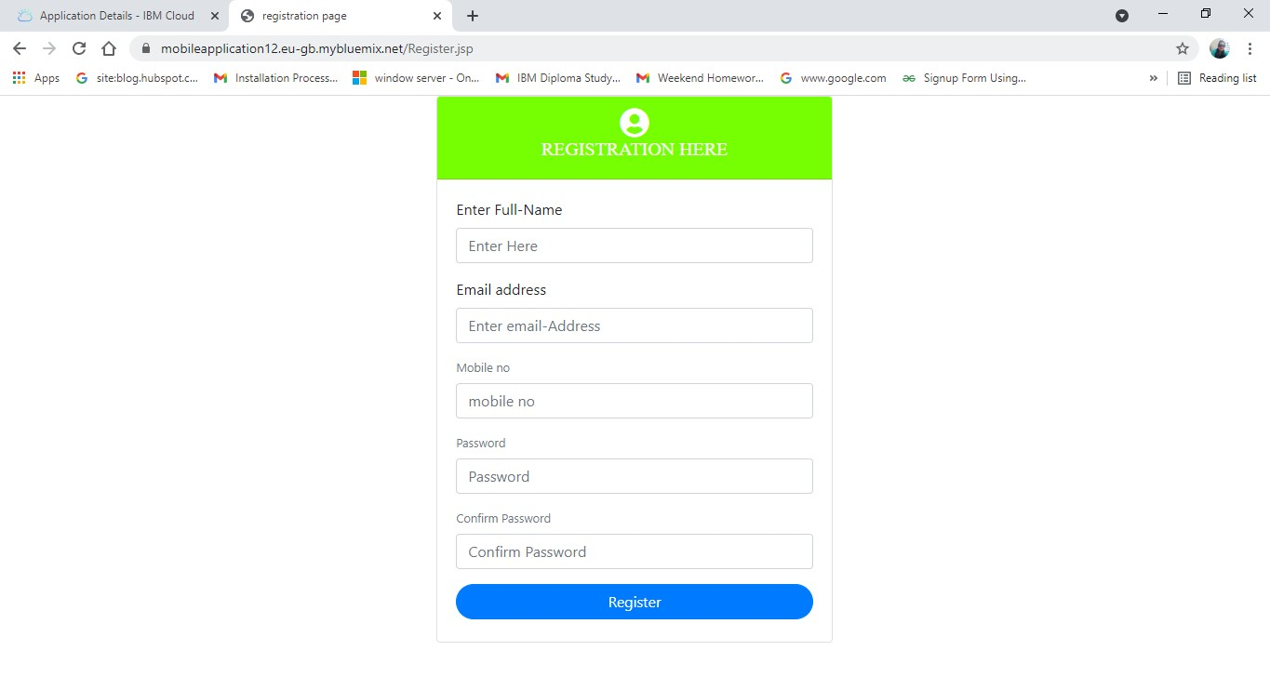

Login page

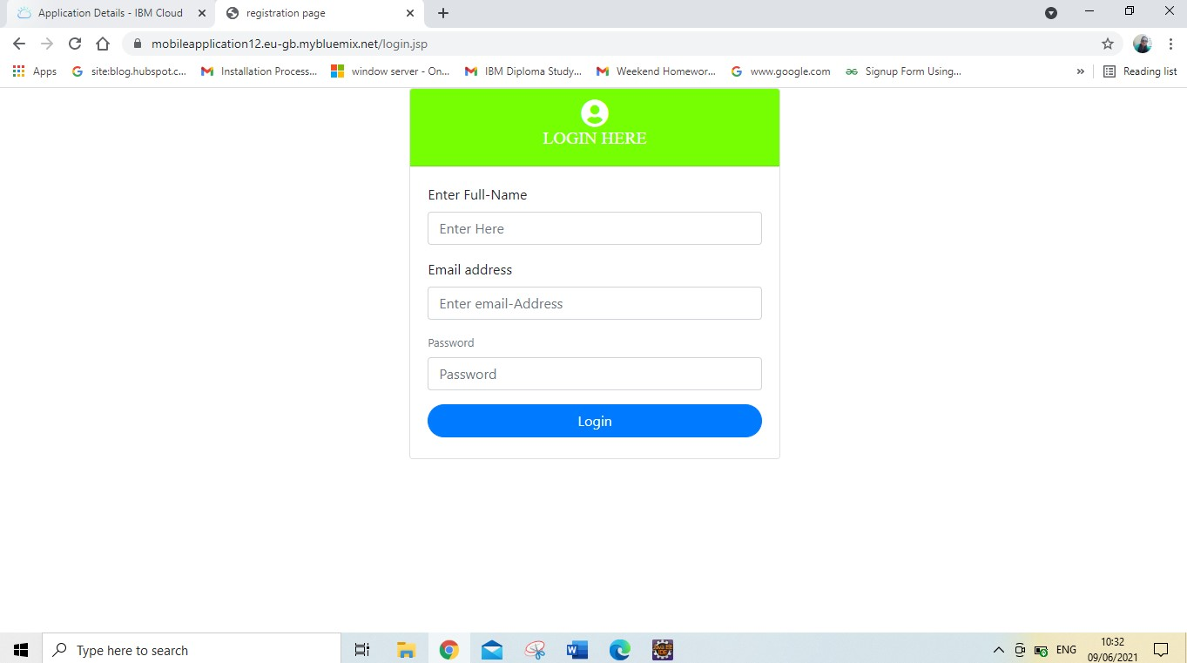

Add contact page

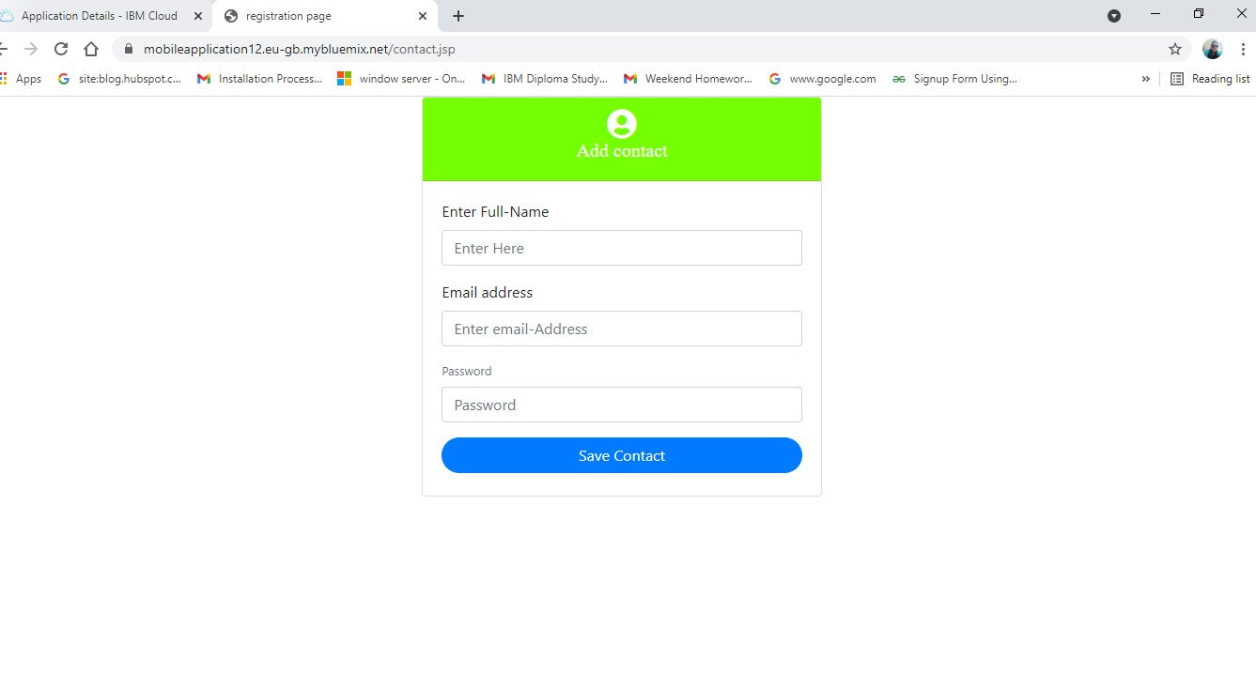

### Source code

Index.jsp

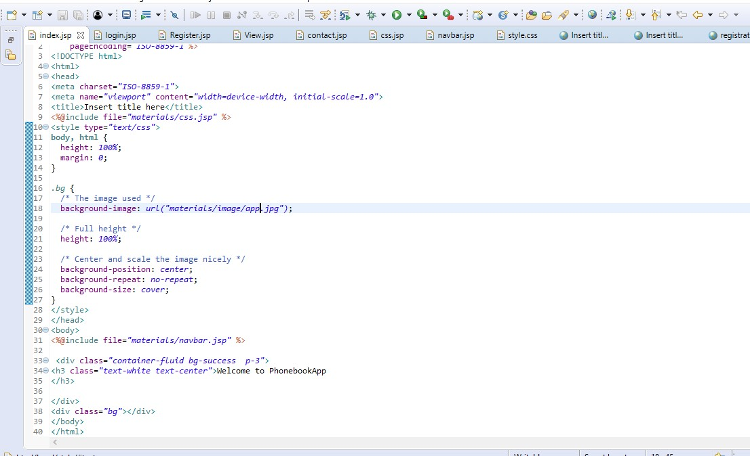

Contact.jsp

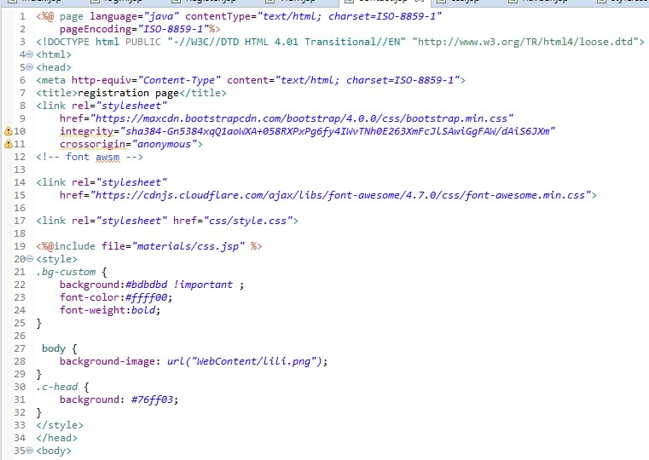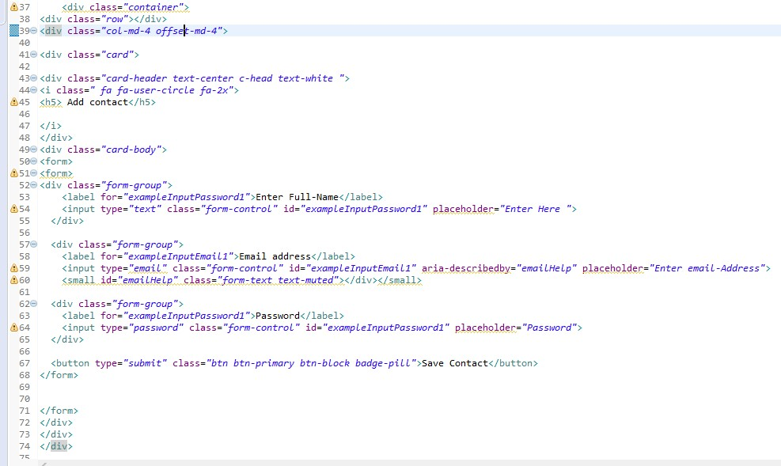

Register.jsp

<%@ page language=*"java"* contentType=*"text/html; charset=ISO-8859-1"*

pageEncoding=*"ISO-8859-1"*%>

<!DOCTYPE html PUBLIC "-//W3C//DTD HTML 4.01 Transitional//EN"

"http://www.w3.org/TR/html4/loose.dtd">

<html>

<head>

<meta http-equiv=*"Content-Type"* content=*"text/html; charset=ISO-8859-1"*>

<title>registration page</title> <link rel=*"stylesheet"*

href=*"https://maxcdn.bootstrapcdn.com/bootstrap/4.0.0/css/bootstrap.min.css"* integrity=*"sha384-*

*Gn5384xqQ1aoWXA+058RXPxPg6fy4IWvTNh0E263XmFcJlSAwiGgFAW/dAiS6JXm"*

crossorigin=*"anonymous"*>

<!-- font awsm -->

<link rel=*"stylesheet"*

href=*"https://cdnjs.cloudflare.com/ajax/libs/font-awesome/4.7.0/css/fontawesome.min.css"*>

<link rel=*"stylesheet"* href=*"css/style.css"*>

<%@include file=*"materials/css.jsp"* %>

<style>

*.bg-custom* {

background:*#bdbdbd !important* ; font-color:*#ffff00*;

font-weight:*bold*;

} **body** {

background-image: *url("WebContent/lili.png")*;

}

*.c-head* {

background: *#76ff03*;

}

</style>

</head>

<body>

<div class=*"container"*>

<div class=*"row"*></div>

<div class=*"col-md-4 offset-md-4"*>

<div class=*"card"*>

<div class=*"card-header text-center c-head text-white "*>

<i class=*" fa fa-user-circle fa-2x"*>

<h5> REGISTRATION HERE</h5>

</i>

</div>

<div class=*"card-body"*>

<form>

<form>

<div class=*"form-group"*>

<label for=*"exampleInputPassword1"*>Enter Full-Name</label> <input type=*"text"* class=*"form-control"* id=*"exampleInputPassword1"* placeholder=*"Enter Here "*>

</div>

<div class=*"form-group"*>

<label for=*"exampleInputEmail1"*>Email address</label>

<input type=*"email"* class=*"form-control"* id=*"exampleInputEmail1"* ariadescribedby=*"emailHelp"* placeholder=*"Enter email-Address"*> <small id=*"emailHelp"* class=*"form-text text-muted"*> </div>

<div class=*"form-group"*>

<label for=*"exampleInputPassword1"*>Mobile no</label>

<input type=*"Number"* class=*"form-control"* id=*"exampleInputPassword1"* placeholder=*"mobile no"*>

</div>

<div class=*"form-group"*>

<label for=*"exampleInputPassword1"*>Password</label>

<input type=*"password"* class=*"form-control"* id=*"exampleInputPassword1"* placeholder=*"Password"*>

</div>

<div class=*"form-group"*>

<label for=*"exampleInputPassword1"*>Confirm Password</label>

<input type=*"password"* class=*"form-control"* id=*"exampleInputPassword1"* placeholder=*"Confirm Password"*>

</div>

<button type=*"submit"* class=*"btn btn-primary btn-block badgepill"*>Register</button>

</form>

</form>

</div>

</div>

</div>

</body>

</html>

#### Login.jsp

<%@ page language=*"java"* contentType=*"text/html; charset=ISO-8859-1"* pageEncoding=*"ISO-8859-1"*%>

<!DOCTYPE html PUBLIC "-//W3C//DTD HTML 4.01 Transitional//EN"

"http://www.w3.org/TR/html4/loose.dtd">

<html>

<head>

<meta http-equiv=*"Content-Type"* content=*"text/html; charset=ISO-8859-1"*>

<title>registration page</title> <link rel=*"stylesheet"*

href=*"https://maxcdn.bootstrapcdn.com/bootstrap/4.0.0/css/bootstrap.min.css"* integrity=*"sha384-*

*Gn5384xqQ1aoWXA+058RXPxPg6fy4IWvTNh0E263XmFcJlSAwiGgFAW/dAiS6JXm"*

crossorigin=*"anonymous"*>

<!-- font awsm -->

<link rel=*"stylesheet"*

href=*"https://cdnjs.cloudflare.com/ajax/libs/font-awesome/4.7.0/css/fontawesome.min.css"*>

<link rel=*"stylesheet"* href=*"css/style.css"*>

<%@include file=*"materials/css.jsp"* %>

<style>

*.bg-custom* {

background:*#bdbdbd !important* ; font-color:*#ffff00*;

font-weight:*bold*;

} **body** {

background-image: *url("WebContent/lili.png")*;

}

*.c-head* {

background: *#76ff03*;

}

</style>

</head>

<body>

<divclass="container>

<div class=*"row"*></div>

<div class=*"col-md-4 offset-md-4"*>

<div class=*"card"*>

<div class=*"card-header text-center c-head text-white "*>

<i class=*" fa fa-user-circle fa-2x"*>

<h5> LOGIN HERE</h5>

</i>

</div>

<div class=*"card-body"*>

<form>

<form>

<div class=*"form-group"*>

<label for=*"exampleInputPassword1"*>Enter Full-Name</label> <input type=*"text"* class=*"form-control"* id=*"exampleInputPassword1"* placeholder=*"Enter Here "*>

</div>

<div class=*"form-group"*>

<label for=*"exampleInputEmail1"*>Email address</label>

<input type=*"email"* class=*"form-control"* id=*"exampleInputEmail1"* ariadescribedby=*"emailHelp"* placeholder=*"Enter email-Address"*> <small id=*"emailHelp"* class=*"form-text text-muted"*> </div>

<div class=*"form-group"*>

<label for=*"exampleInputPassword1"*>Password</label>

<input type=*"password"* class=*"form-control"* id=*"exampleInputPassword1"* placeholder=*"Password"*>

</div>

<button type=*"submit"* class=*"btn btn-primary btn-block badge-pill"*>Login</button> </form>

</form>

</div>

</div>

</div>

</body>

</html>

*Css.jsp*

<link rel=*"stylesheet"* href=*"https://maxcdn.bootstrapcdn.com/bootstrap/4.0.0/css/bootstrap.min.css"* integrity=*"sha384-*

*Gn5384xqQ1aoWXA+058RXPxPg6fy4IWvTNh0E263XmFcJlSAwiGgFAW/dAiS6JXm"* crossorigin=*"anonymous"*>

<script src=*"https://code.jquery.com/jquery-3.2.1.slim.min.js"* integrity=*"sha384-*

*KJ3o2DKtIkvYIK3UENzmM7KCkRr/rE9/Qpg6aAZGJwFDMVNA/GpGFF93hXpG5KkN"*

crossorigin=*"anonymous"*></script> <script src=*"https://cdnjs.cloudflare.com/ajax/libs/popper.js/1.12.9/umd/popper.min.js*

*"*

integrity=*"sha384-*

*ApNbgh9B+Y1QKtv3Rn7W3mgPxhU9K/ScQsAP7hUibX39j7fakFPskvXusvfa0b4Q"*

crossorigin=*"anonymous"*></script>

<script

src=*"https://maxcdn.bootstrapcdn.com/bootstrap/4.0.0/js/bootstrap.min.js"* integrity=*"sha384-*

*JZR6Spejh4U02d8jOt6vLEHfe/JQGiRRSQQxSfFWpi1MquVdAyjUar5+76PVCmYl"*

crossorigin=*"anonymous"*></script>

<link rel=*"stylesheet"*

href=*"https://cdnjs.cloudflare.com/ajax/libs/fontawesome/5.15.3/css/all.min.css"* integrity=*"sha512-*

*iBBXm8fW90+nuLcSKlbmrPcLa0OT92xO1BIsZ+ywDWZCvqsWgccV3gFoRBv0z+8dLJgyAHIhR35VZc2oM/gI1 w=="*

crossorigin=*"anonymous"* referrerpolicy=*"no-referrer"* />

<link rel=*"stylesheet"*href=*"style.css"*>

Navbar.jsp

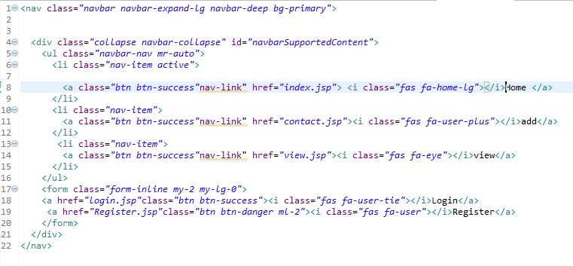

## Conclusion

The aim of this project was to build a Telephone directory through which allowed to add, register and view all contacts of individual.

The almost care and backup procedures must be established to ensure 100% successful implementation of the computerized restaurant phonebook application.

This system is developed using the general need required by the user while using the phone directory book and provided a lot of facility to their user. The objective of my Project Phone Book is to record the details various activities of user. It will simplify the task and reduce the paper work.

**R E F E R E N C E S**

[*https://getbootstrap.com/docs/4.0/getting*](https://getbootstrap.com/docs/4.0/getting)[*-started/introduction/*](https://getbootstrap.com/docs/4.0/getting-started/introduction/) [*https://cloud.ibm.com/account/cloud-foundry*](https://cloud.ibm.com/account/cloud-foundry)

[*https://youtu.be/wsWWDsoz0fY*](https://youtu.be/wsWWDsoz0fY)

Thank You..